Listening Section
In this section of the test, you will have the chance to show how well you understand spoken English. There are four parts to this section, with special directions for each part.
Part I
Questions 1 to 4
Directions:
In this part of the test, you will hear some dialogues spoken in English. The dialogue will be spoken twice. They will not be printed in your test book, so you must listen carefully to understand what the speakers are saying.
After you hear a dialogue and the question about it, read the five possible answers and decide which one would be the best answer to the question you have heard. Now listen to a sample question.
You will hear:
Man : Are you free on Saturday morning?
Woman: Yes. Any plan to do?
Man : We’ll see a book fair at JCH. Do you care to join?
Woman: I’d love to.

You will also hear:

Narrator: What are the speakers talking about?
Sample answer
You will read in your test book:
A B C D E

- Loving books
- Asking free time
- Buying some books
- Planning to see book fare
- Activity on Saturday morning

The best answer to the question “What are the speakers talking about?” is choice (D). Therefore, you should answer choice (D)
1.
- Dina’s winning the speech contest
- The man’s winning the speech contest
- The woman’s practicing for a speech contest
- Dina’s practicing for a speech contest
- Their practicing for a speech contest
2.
- He is sick
- He is healthy
- He is hospitalized
- He is being recovered
- He is being taken care.
3.
- Report discussion
- Annual discussion
- Weekly report
- Annual report
- Daily report
4.
- He is sick
- He is healthy
- He is hospitalized
- He is being recovered
- He is being taken care.

Part II
Questions: 5 to 7
Directions:
In this part of the test, you will hear several questions or statements spoken in English followed by four responses, also spoken in English. The questions and responses will be spoken twice. They will not be printed in your test book, so you must listen carefully to understand what the speakers are saying. You have to choose the best response to each question or statement.
Now listen to a sample question:

You will hear:
Man : You look uncomfortable.
Woman: It’s very hot here.
Woman: I’ll switch on the fan for you.
Man :
Sample answer

A B C D
You will also hear:

- I’ll be glad.
- I’ll be happy.
- Thank you.
- It’ll be okay.

Narrator: What is the best response to the woman’s statement?
The best response to the woman’s statement “I’ll switch on the fan for you.” is ” (Thank you.) Therefore, you should answer Choice “C”.

5. Mark your answer on your answer sheet.
6. Mark your answer on your answer sheet.
7. Mark your answer on your answer sheet.

Part III
Questions 8 to 10.
Directions:
In this part of the test, you will hear some monologues spoken in English. The monologues will be spoken twice. They will not be printed in your test book, so you must listen carefully to understand what the speakers are saying.
After you hear the monologue and the questions about it, look at the pictures and decide which one would be the best answer to the question you have heard.
8.

A B

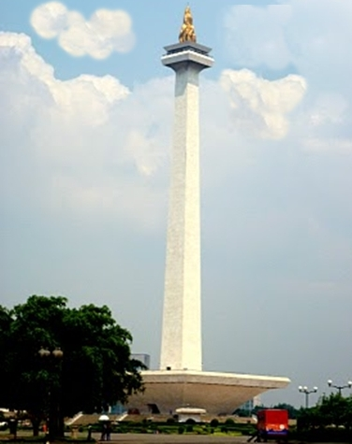 | 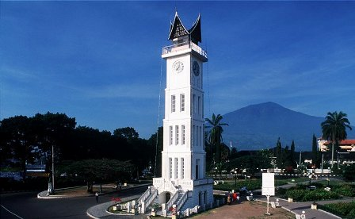
C  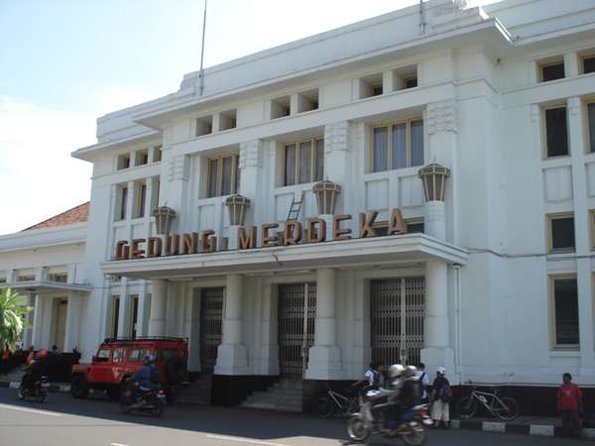 | D  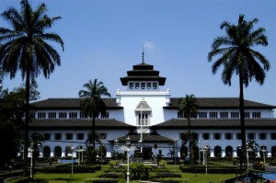
E
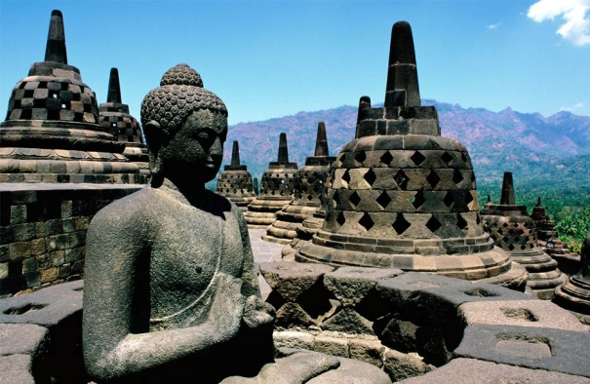

9.

A B

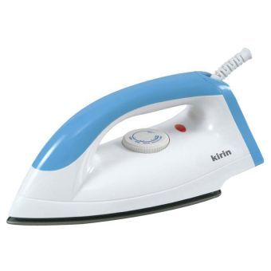 | 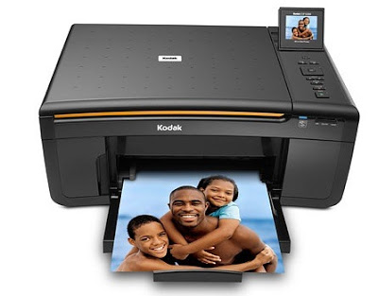
C | D
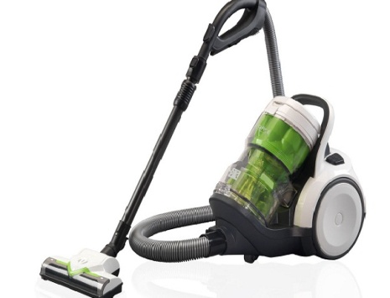
E
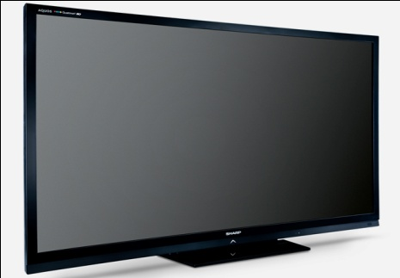

10.
A B C D E
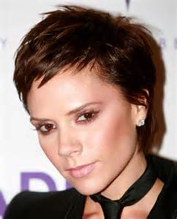 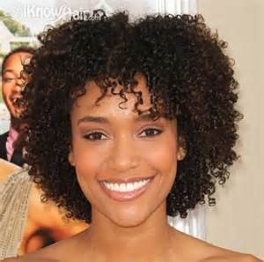

11.

A. | B. 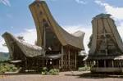 | C. | D.  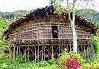 | E.

Part IV
Questions 12 to 15
Directions:
In this part of the test you will hear several monologues. Each monologue will be spoken twice. They will not be printed in your test book, so you must listen carefully to understand what the speakers are saying.
After you hear the monologue and the questions about it, read the five possible answers and decide which one would be the best answer to the questions you have heard.

- Nyi Loro Kidul
- Sangkuriang
- Jaka Tarub
- Bandung Bondowoso
- Tangkuban Perahu

- At Tangkuban Perahu
- At Citarum River
- At a small village
- At Bandung City
- At Dayang Sumbi’s house

- What are the speakers talking about?

A. The Yonkers Arson Squad.
B. The blaze at the shoe store
C. A fire in the shopping center
D. A shopping center in the cross county.
E. The largest shopping center in Westchester County.

- How many fire fighters were involved in the scene?

A. Four
B. Five
C. Six
D. Seven
E. Eight
THIS IS THE END OF THE LISTENING SECTION

Reading section
The following text is for questions 16 and 17

ATTENTION
To apply for a new drive license, come to the BRI to buy a form. Then bring the form you’ve completed to the license office Monday through Friday between 8.00 a.m. and 2.30 p.m. You will take a written test and a driving test after you fill in other forms from the license office. There will be a fee but not much.

16. The announcement mainly informs … to get a new driving license.
- What requirements should one fulfill
- What kinds of test should one take
- Where should one buy the form
- How much should one pay
- What one should do

17. What must be done before taking the written and driving test ?
- send to the license office Buy the license form
- pay a drive license fee
- Buy the license form
- Come to the BRI
- fill in the forms

The following text is for questions 18 and 19
Dear Diego,
Thank you very much for letting me used your apartment while you were away. I tried to leave everything just as I found it. You will unfortunately, find one thing missing. I wanted to do you a favor by cleaning the living room. While I was dusting that beautiful bowl you keep on the office table, it fell out of my hand and broke.
I am terribly sorry about breaking your bowl. I know that it was a present from your grandmother and that it means a lot to you. Things like that are irreplaceable. I think, however, that the bowl can be fixed. It broke into just three large pieces. I have a friend who is an expert on valuable chine, and I have given her the bowl to repair. You should have it back in a few days, and I think it will look as good as new.
I hope this solution is satisfactory to you. Again, I am so very sorry this happened. I will bring you the bowl soon.

Your friend,
Michael

- What is the purpose of the letter?
- Diego and Michael are best friends
- To tell Michael that Diego’s bowl had been broken
- To tell Diego that Michael had been used his apartment
- Michael thanked and asked apology to Diego for his fault
- Diego thanked to Michael for helping him kept his apartment

- Why did Michael ask apology from Diego? Because ....
- He broke his promise.
- He stole Diego’s bowl.
- He broke Diego’s bowl.
- He used Diego’s apartement.
- He was dusting his beautiful bowl.

The following text is for questions 20 to 22.

A Biography of An Internet Enterpreneur

Jan Koum is an American internet enterpreneur and computer engineer. He is the CEO and co-founder with Brian Acton of Whatsapp, a mobile messaging application which was acquired by Facebook Inc. in February 2014 for US $ 19 Billion.
Koum was born in Kylv, Ukraine on February 24, 1976. He is a Jewish. He grew up in Fativ, outside Kylv, and moved with his mother and grandmother to Mountain View, California in 1992, where a social support program helped the family to get a small two- bedroom apartment, at the age of 16. His father had intended to join the family later, but finally remained in Ukraine. At first Koum’s mother worked as a babysitter, while he himself worked as a cleaner at a grocery. By the age of 18, he became interested in programming. He enrolled at San Jose State University and simultaneously worked at Ernst and Young as security tester.
In 1997, Jan Koum was hired by Yahoo as an infrastructure engineer, shortly after he met Brian Acton while working at Ernst & Young as a security tester. Over the next nine years, they worked at Yahoo. In September 2007 Koum and Acton left Yahoo and took a year off, traveling around South America and playing ultimate frisbee. Both applied and failed to work at Facebook. In January 2009, he bought an iPhone and realized that the then-seven-month-old App Store was about to spawn a whole new industry of apps. He visited his friend Alex Fishman and the two talked for hours about Koum’s idea for an app over tea at Fishman’s kitchen counter. Koum almost immediately chose the name WhatsApp because it sounded like “ what’s up “, and a week later on his birthday, Feb 24, 2009, he incorporated WhatsApp Inc. in California.
WhatsApp became popular in just a small amount of time, and this caught Facebook’s attention Facebook’s founder, Mark Zuckerberg first contacted Koum in the spring 2012. The two began meeting at a coffee shop in Los Altos, California, then began a series of dinners and walked the hills above Silicon Valley.
On February 9, Zuckerberg asked Koum to have dinner at his home, and formally proposed Koum a deal to join the Facebook board.
His mother died in 2000 of cancer in the United States, while his father died in Ukraine in1997.
In 2014, he entered the Forbest list of the 400 richest Americans at position 62, with an estimated worth of more than seven and half billion dollars. He was the highest-ranked newcomer to the list that year.

20. What does this passage talk about mostly?
A. Jon Koum’s life
B. Mark Zuckerberg
C. WhatsApp and Facebook
D. Jon Koum and Brian Acton
E. How Mark Zuckerberg approached Jon Koum

21. Jon Koum found WhatsApp with his partner Brian Acton. What is WhatsApp?
A. a mobile messaging application which was acquired by Facebook Inc.
B. Application that Jon found in iPhone first time he had that phone.
C. Words taken from the expression “ What’s up? “
D. Jon’s and Acton’s place of work
E. Part of Facebook program

22. They will improve the road and electricity power of this city soon. What is the word from the passage above that can replace the words underlined in the sentence?
A. simultaneously
B. enterpreneur
C. infrastructure
D. spawn
E. industry

The following text is for questions 23 to 25.

How to supply power in your cell phone

First, open the cover of the cellular phone. Then insert the SIM card after being installed. Next, insert the battery inside. Before you connect the lead from the charger to the bottom of the cellular phone, close the battery with a cover of it. Connect the charger to an AC wall outlet. Charging the battery supplied with the phone may take four up to six hours. When the battery is fully charged, the bar stops scrolling. Then disconnect the charger from the AC outlet and the phone. Finally we are ready to make a phone call.

- What does the text mainly about?
- Tips how to activate a cellular phone
- Instruction how to make a cell phone
- Explanation how to get a cellular phone
- Description how to insert a memory card
- Instruction how to charge the phone battery

- What should we do after inserting the SIM card?
- open the cover of the cell phone
- close the battery with a cover
- disconnect the charger
- insert the battery inside
- turn the cell phone on

- “...close the battery with a cover of it.”
What does the word it refer to?
- the phone
- the battery
- the charger.
- the AC outlet.
- The cellular phone

The following text is for questions 26 to 28

Soccer Story

When I was nine, my soccer team went to a tournament in South Portland. The only reason we got there was because we didn’t lose a game during the regular season. The first game was easy for my team. We beat Biddeford five to one. I got one goal and one assist. My friend Patrick got a hat trick, and Bailey got a goal also.

The next game was a lot tougher. We played Westbrook and beat them one nil. I played goalkeeper for the entire game. My teammate Josh is the one who scored the only goal of the game. We barely made the playoff. We were tied with two other teams, but we had more goals than they did so we got to move on.

The third game was the hardest yet. We would get a goal then they would. This went on for about four goals then finally my team scored two in a row. This game we played Bonny Eagle, and the final score was four to six. Our team won, so we went on to semifinals and played the Massabesic team. We tied them, so we went onto sudden death. In sudden death they took out one of our midfielders in the box. We got a penalty kick. Our best player took the kick and put it right in the top corner.

We won, and we’re going to the finals! We played Saco. It was the toughest game I had ever played as a goalie. I saved eighteen shots. The game was tied until the final minute when our best player scored. It was one to zero with 56 seconds left. The other team set up for an attack play. They had seven on offense. They rushed up the field, got past the defense and shot. I saved the first shot but not the second. They tied the game. We had OT but neither team scored. We went into a penalty shoot out. Our team got all our shots in, and saved three of the other team’s shots. We won the finals. We got medals and t-shirts saying that we were the champions.

We won the South Portland tournament.

(https://sites.google.com/a/berwickacademy.org/lcarusa/home/personal-experience-stories

- How were the writer and his team going to the finals?
- they won the second game
- they won the third game
- they won the first game
- they got penalty kick
- they played Saco

- What is the main idea of paragraph one?
- The writer’s soccer tournament in South Portland.
- The writer and his team played Westbrook and beat them one nil.
- The game was tied until the final minute when our best player scored.
- The writer and his team played Bonny Eagle, and the final score was four to six.
- The writer and his team got medals and t-shirts saying that we were the champions.

- From the text, we know that the writer is … of the team.
- A striker
- A captain
- A goal keeper
- A Middle player
- The best player

The following text is for questions 29 to 31.

Queen Aji Bidara Putih

Muara Kaman lies along the Mahakam River, in eastern Borneo. In the past the area was a kingdom ruled by Queen Aji Bidara Putih. She was a typical queen of myths: beautiful, wise, and sensitive. Many princes and kings proposed to her but she always refused them because she was more concerned with ruling her country and guarding her people.
One day, a Chinese boat came to eastern Borneo. First, the people thought it was a merchant ship but the boat was loaded with trade goods and highly trained soldiers. Their envoys brought gold and porcelain to announce the marriage proposal from a prince of China. The queen didn’t refuse instantly and replied that she had to ponder the proposal first.
After the envoys left the palace, the queen called a court officer and ordered him to infiltrate the Chinese boat to gather information on the prince. When night fell the officer sneaked onto the boat, got by all the guards, and finally found the prince’s room. The large door would not open and he couldn’t find a peek hole, so the officer put his ear to the wall, trying to catch sounds from inside. He heard that the prince was having his dinner and the noise of his chewing and slurping surprised the officer. It was like a boar that he had once heard when he was hunting.
He quickly left the boat and returned to the palace. He reported that the prince must have been a phantom, not a human. He believed that the phantom could be in a human’s form only during the daytime. The queen was so surprised and got angry.
On the next day, she refused his proposal. The enraged prince ordered his troops to raid Muara Kaman. The battle was won by the prince’s huge band of troops. As they drew near to the palace, Queen Aji Bidara Putih chewed a leaf of betel vine and sang a mantra while holding it. When she threw it at the Chinese troops, it turned to giant centipedes. The Chinese troops started to retreat but three centipedes chased them and sank the boat. The site of the sunken ship is now known as Danau Lipan (Lake of Centipedes), with Chinese treasures hidden on the lake’s bed.

- Where did the story take place?
- In the area that is now called Muara Kaman
- In the Lake of Centipedes
- In a kingdom in China
- In western Borneo
- In Mahakam river

- Why did the envoys bring gold and porcelain?
- load their ship
- to trade them for stocks
- to sell them to the queen
- to share them with the residents
- to announce the marriage proposal from a prince of China

31. What can we learn from the story?
- It is necessary to be honest before you begin a relationship.
- The cruel will damage everything you have.
- Honesty is more than everything.
- You have to fight for a true love.
- You should believe on yourself.

The following text is for questions 32 to 35

GIRAFFE

Giraffe is the highest animal in the world. Its height can reach 4.8 to 5.5 meters and its weight about 1360 pounds. Giraffe has a unique characteristic. They have a very long neck and two small horns on its head. Giraffes have big brown eyes and protected by thick and long eyebrows. Her body is covered with a unique pattern that is attached by brown spots all over their body.
Just like camels, giraffes can survive without drinking for long time because giraffes can rely on the water contained in leaves they eat. Giraffes are very selective in choosing food. They always eat young leaves that grow in the tree tops. Their tongue shaped like a knife help them to cut branches which are very hard.
Female giraffes can start pregnant at the age of five years, with a gestation period of 15 months. Commonly female giraffe bear one baby, but sometimes two babies at once. Giraffes bear its baby with a standing position. When the baby is about to be born, they just drop it to the ground from a 1.5 meter of height. Baby giraffe can stand with about 20 minutes since being born, and begin breastfeeding within an hour of birth.

- The text tells us about ….
- Giraffe’s reproduction
- The strange animals
- The heaviest animal
- Baby giraffe
- Giraffe

- The unique characteristic of giraffe is ….
- Two horns on its head
- Their long neck
- Brown spot
- Their food
- Their life

- Why can girrafes survive without drinking for long time? It because....
- when the girrafes born the baby, they they just drop it to the ground from a 1.5 meter of height
- female giraffe can bear one or two babies at once
- they consume water containing leaves
- they are selective in choosing food
- Their tongue look like a knife

35. From the text above, we can conclude that ….
- The gestation period of female giraffe is 5 months
- The mature female giraffe is in the age of six
- Giraffe is the tallest mammal in the world
- Giraffe needs a big amount of water
- Baby giraffe bears in all position

The following text is for questions 36 to 38

Laptop as Teacher’s Best Buddy

Traditionally, teacher brings text book, ruler and such other stuff. Moreover, in this multimedia era, teachers need more to reach their teaching goal. Teachers need power point to present the material easily. Of course it will need more time to type but it will deserve for its function.
Additionally, modern teachers tend to apply fast transferring knowledge to the students because the teachers need to catch the target of curriculum. Every subject will tend to be given in demonstrative method. Consequently teachers need extra media to present the subject gratifyingly. Since there is a laptop used by the teachers, it will help them to create some teaching aids for the students to get better understanding.
Finally, finding an appropriate laptop which has gigabytes of memory is not difficult as it was. Recently there is an online shop which provides comprehensive information. The best is that the shop has service of online shopping. The teachers just need to brows that online shop, decide which or laptop they need, then complete the transaction. After that the laptop will be delivered to the teachers' houses or office. That is really easy and save time and money.
Based on the arguments above having laptop is absolutely useful for teachers who want to reach the best result for their teaching. Buying laptop online is advisable because it will cut the price. This online way is recommended since online shop also provide several laptop types. Teachers just need to decide which type they really need.

- Why do modern teachers need a laptop?
- To help them to apply fast transferring knowledge to the students
- To reach their best result for their studying
- To present power point in front of them
- To make the students feel awesome
- To make them proud of us

- The main idea of paragraph three is …
- It is easy to buy laptop.
- Laptop is easy to find.
- We can buy laptop online.
- Laptop is very useful device.
- Laptop is cheaper thing to buy.

- Traditionally, teacher brings text book, ruler and such other stuff . What does the italic word mean?
- pen
- book
- things
- pencil
- eraser

The following text is for questions 39 to 42

(SATIBI/SMA CINTA KASIH TZU CHI)

Jakarta: A man was killed in a collision between a bus and a motorcycle. Toni Saptian (49) was found dead at the site after the scene of the accident. At that time, he was driving a Suzuki Skywave motorcycle.
The accident, occurring in industrial areas, Plumpang, Jakarta Utara, attracted people’s attention while they were passing by. An eyewitness said, “I was surprised to hear the loud crash and the sound of tires screeching. Then, I saw a man lying on the road suffering from severe injuries to his head. He died then and there.” The local police officer, AKP Turyono, explained the chronology of the accident. “He went through the busway lane. Then, he slipped because the separator is too high. A bus came from behind. It was too close for the bus to stop.”
This incident is still under investigation by North Jakarta police. The victim was immediately brought to Cipto Mangunkusumo Hostipal (RSCM).

- What does the text talk about?
- A bus accident
- A motorcycle accident
- A man killed in a collision
- The accident in industrial area
- The victim was immediatly brought to RSCM

- Who was immediatly brought to RSCM?
- The man on the street
- The police officer
- The bus driver
- AKP Turyono
- Toni Saptian

- What is the main idea of the second paragraph?
A. There was an accident in Plumpang.
B. The accident happened due to a man slipped.
C. The witness was surprised to hear the loud crash.
D. The accident in Plumpang attracted people’s attention.
E. The chronology explanation from the local police officer.

- What was the cause of the collision?
A. The bus didn’t use its light.
B. The brakes of the bus malfunctioned.
C. The motorcycle slipped on the busway
D. The rider carried more than two people.
E. The motorcycle tried to overtake the bus.

The following text is for questions 43 to 45

The Centres for Disease Control ( CDC ) recommends getting 28 doses of 10vaccines for kids aged 0 to six. No US federal laws mandate vaccination, but all 50 states require certain vaccination for cildren entering public schools.
Most states offer medical and religious exemptions; and some states allow philosophical exemptions. Proponents say that vaccination is safe and one of the greatest health developments of the 20th century. They point out that illnesses, including rubella, diphtheria, smallpox, polio, and whooping cough, are now pevented by vaccination and millions of children
‘s lives are saved. They contend adverse reactions to vaccines are extremely rare.
Opponents say that children’s immune systems can deal with most infections naturally, and that injecting questionable vaccine ingredients into a child may cause side effects, including seizures, paralysis, and death. They contend that numerous studies prove that vaccines may trigger problems like autism, ADHD, and diabetes.
( source : http://vaccines.proco.org)

- Why do CDC recommend getting 28 doses of 10 vaccines for kids aged 0 to six ?
- The numerous studies prove that vaccines may not a trigger problems like autism, ADHD, and diabetes.
- The adverse reactions to vaccines are extremely rare.
- The vaccinations are very important for people.
- All diseases are prevented by vaccination.
- Vaccinations for children is a necessity.

- What is the reason of people that vaccination is not important?
- Vaccination is safe.
- Certain diseas cn be prevented by vaccination.
- Vaccines ingredients may not cause side effects.
- They point out that illnesses are now prevented by vaccines.
- Children’s immune system can deal with most infections naturally.

- What does the third paragraph tell about ?
- The important of vaccine for kids.
- The advantages of executing vaccine for kids
- The disadvantages of executing vaccine for kids.
- The against issue for beneficial of vaccine for kids.
- The proponent issue for beneficial of vaccine for kids.

46. Rearrange the jumble sentences to make a meaningful text.

How can I download YouTube videos and save them on my computer?
- Insert the video link in clip Grab. after copying the link, switch to the Clip grab window. in the "Downloads" tab, insert the copied link into the input field. you can do this by hitting Ctrl+V (or Cmd+V if you are on a Mac). Clip Grab will now gather all necessary information about the video and you can proceed to the next step.
- Install ClipGrab. First of all, you need to install ClipGrab . ClipGrab is a 100 % free and easy to use YouTube downloader and available for Windows, Mac and Linux. Click on the button to initiate the download.
- Select download format and quality. Before you start the download, you can now decide in which quality and which output format you want to save the video. just select the desire format from the "format" select the box and do the same for the video quality with the "quality" select box.
- Install Clip Grab. First of all you need to imstall clip Grab. clip grab is 100 % free and easy to use you tube down loader and available for windows, Mac and Linux on the button to initiate the down load.
- Copy the video link. after you have sucessfuly set up Clip Grab, you can launch the program. now you need to copy the web address of the video that you want to download. in order to do that, mark the link to the video in the address bar of your browser and hit Ctrl+C (or Cmd+C if you are on a Mac.

The best arrangement of the sentences is …
- 1-2-3-4-5
- 2-4-1-3-5
- 3-5-1-2-4
- 3-5-1-4-2
- 3-5-4-1-2

47.Rearrange these jumbled sentences into a meaningful text!

- On the second day we went to Tabuhan cave.
- Last week my family and I went to Pacitan.
- We could hear the sounds of gamelan after hitting stalactites and stalagmites.
- We had got the amazing journey.
- Pacitan is my homeland.
- On the first day, we went to our relative’s house.
- Their houses are in the hills, we liked walking to go there.
- At the last day we went home.

The best arrangement of the sentences is …

- 2 – 5 – 6 – 7 – 1 – 3 – 8 – 4
- 2 – 6 – 5 – 7 – 1 – 8 – 3 – 4
- 5 – 2 – 6 – 7 – 1 – 3 – 8 – 4
- 5 – 6 – 2 – 1 – 7 – 3 – 4 – 8
- 2 – 5 – 7 – 6 – 3 – 1 – 4 – 8

The following incomplete text is for questions 48 to 50.

Complete the text with the correct words.

The last day of school is a fun time but also a little sad too. It is an exciting time because you are officially on summer break, but you have to say goodbye to your friends until you get together over the summer. The locker area is crowded with people (48). …. and saying goodbye. People are also packing their bags full with everything from their lockers. The blue lockers are left to stand empty just as they were in the beginning of the year. Backpacks are full of everything from pencils to textbooks and even notecards from the beginning of the year. I am glad my backpack has wheels, so I did not have to put strain on my back. I am (49) …. to go on my family vacation and have my birthday party. As I look back on it now, I feel just the same way as I was at the time, happy but sad. As I said (50)…. to my friends I walked out the door rolling my backpack behind me. As soon as I smelled the fresh warm air I knew it was going to be a great summer!

(https://sites.google.com/a/berwickacademy.org/lcarusa/home/personal-experience-stories)

48.
- hug
- hugged
- hugging
- was hugging
- being hugged

- sad
- scared
- excited
- jealous
- anxious

50.

- goodbye
- good night
- good morning
- good afternoon
- good evening

